To what extent does the frequency of an alternating current affect the time taken to demagnetize a temporarily magnetized iron rod?

This investigation aims to determine the relationship between the time taken to demagnetize a temporary magnet and the frequency of alternating current. First, a soft rod was magnetized to a fixed strength by using a DC Solenoid. After that, 5 nails were attached to one end of the rod. Then, to demagnetize rod, it was kept in an AC current solenoid at specific frequencies. I have always found the link between electricity and magnetism extremely interesting because of how interrelated they are. Changing electric and magnetic fields induce each other, and even light rays are just oscillating electric and magnetic fields. Because of such an interlinked relation, I have always been interested in the concept of electricity and magnetization. That’s why I decided to investigate the relation further in my IA. I chose to investigate the relationship between time taken to demagnetization and frequency of AC current because it is extremely important in the world. For example, in naval ships and submarines degaussing is used to remove magnetic signatures. The degaussing process involves passing AC current through large coils surrounding the vessel.

**Research Question**: To what extent does the frequency of an alternating current affect the time taken to demagnetize a temporarily magnetized iron rod?

**Background information**

**What are Magnets and how do they form?**

This investigation revolves around magnets and magnetism. Magnets are objects that have a magnetic field of their own. These objects are usually made of ferromagnetic materials such as iron, nickel, cobalt or their alloys. The reason only ferromagnetic materials form magnets is due to the presence of magnetic domains, defined as the region in which the magnetic fields of atoms are grouped together and aligned.

Magnetic domains arise due to the spin and orbital motion of electrons. Each electron has its own magnetic moment due to its spin, and when electrons are paired their magnetic moments cancel out, since their spin is in opposite directions.

Ferromagnets have unpaired electrons in the d-subshell. Because of which, the atoms’ magnetic field is not canceled out and magnetic domains form. When all these domains align in the same direction the magnetic fields add up to form a larger magnetic field, from which the entire body gets magnetized.

Other materials such as copper or wood do not get magnetized because they do not have unpaired electrons in the d-subshell. However, materials with unpaired electrons in the p subshell like oxygen (2 unpaired electrons in p subshell) have paramagnetic properties, which means that magnetic properties are present, but they are very weak.

**How the DC current passing through the solenoid magnetizes the iron rod**

Furthermore, in this investigation a soft iron rod is magnetized and demagnetized using a solenoid. The solenoid can do so because of the type of current passing through its coil.

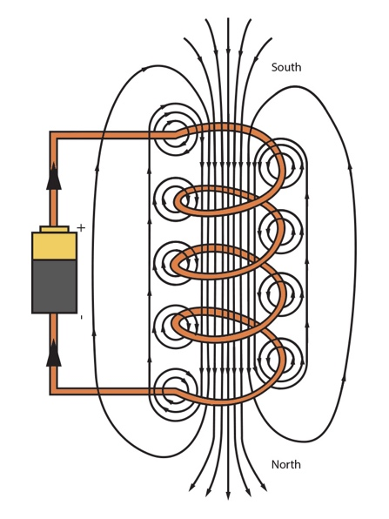

Fig 1.1

The solenoid magnetizes the rod when DC current is passed through it.

Fig 1.1 demonstrates how a magnetic field forms in a solenoid when Direct current passes through it. As charges pass through the wire, individual magnetic fields are produced. These fields add up to form a larger magnetic field.

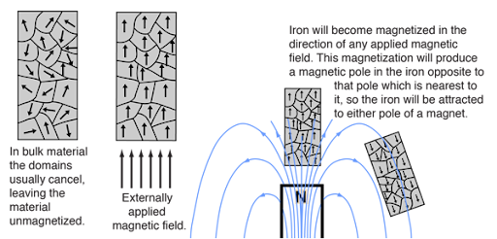

Fig 1.2

Since the iron rod is placed within the solenoid, the solenoid’s magnetic field aligns all the magnetic domains in the iron rod and magnetizes it, demonstrated in Fig 1.2. The iron rod then remains magnetized even after the DC current is switched off as its domains are still aligned.

**How the AC current passing through the solenoid demagnetizes the iron rod**

Fig 1.3

On the other hand, to demagnetize the rod, AC current is passed through the solenoid. When passing AC current, the direction of the current keeps changing. As a result, the direction of the solenoid’s magnetic field keeps changing, as seen in Fig 1.3. This alternating magnetic field disrupts the alignment of the domains and demagnetizes the iron rod.

**Hypothesis**

According to the concept, the AC current will generate an alternating magnetic field which will demagnetize the rod by misaligning all the magnetic domains. According to that, AC current with a higher frequency should demagnetize the rod faster because at higher frequencies the magnetic field will alternate faster, causing the magnetic domains to misalign faster. However, after a trial run with very high frequency (102.5Mhz), the rod did not get demagnetized. That could be because at such high frequency the alternating magnetic field did not have any time to have any effect on the rod. Since the duration of the magnetic field in one direction lasts so short, the resultant magnetic field essentially cancels out.

Thus, my prediction is that for frequencies on the lower end, like the ones taken in this investigation, there will be a negative trend between frequency and time taken to demagnetize.

**Variables**

**Independent -**

The independent variable is the **frequency of the alternating current** applied to a solenoid. This will be varied across multiple values: 10z, 30hz, 50hz, 70hz, and 90hz to study its effect on demagnetization rate. The values will be varied and controlled using an AC current source. Values at the lower end were chosen since higher frequencies stopped having any effect on the rod. To ensure a reliable relation is observed, the range at the lower end was taken.

**Dependent -**

The dependent variable is the **time taken for the magnetized iron rod to lose its magnetism**. This will be obtained by measuring the amount of time taken for all the 5 iron nails to fall off the iron rod. The reason for measuring the time taken for all 5 nails to fall off is that at different frequencies the demagnetization gradient of the rod could be different and could cause 1 or 2 nails to fall off randomly, also nails could fall due to some external disturbance like hitting the table or the solenoid being touched. To ensure that only time taken to demagnetize the entire rod is measured, the stopwatch is stopped only after 5 nails fall off.

**Control Variables**

|  |  |  |
| --- | --- | --- |
| **Variable** | **Reason** | **How it will be controlled** |
| Current and Voltage passed of DC current passed through solenoid | Varying the current and voltage would affect the strength of the solenoid’s magnetic field, in turn it would affect the magnetic strength of the rod | The same values will be used for all trials |
| Current and Voltage passed of AC current passed through solenoid | Varying the current and voltage would affect the strength of the solenoid’s magnetic field, in turn it would affect the time taken to demagnetize the rod. | The same values will be used for all trials |
| Amount of time that rod was inside the solenoid | Changing amount of time could also affect the magnetic strength of the rod | The rod will be kept inside the solenoid for the same amount of time for all trials |
| Magnetic Strength of Rod | If the strength varies, then the values for time taken to demagnetize will not be reliable | The rod was magnetized to approximately the same strength ( 2mG) by either demagnetizing the rod completely and re-magnetizing it or keeping the rod in the DC solenoid for longer . |
| Size of nails | Varying sizes of nails will not give reliable results, as larger masses will require larger magnetic strength | Nails of the same size will be used throughout the investigation. |
| Size of the rod | Different sizes will lead to different magnetic strengths | The same rod will be used for all the trials in the investigation |
| Positioning of Gauss meter | The strength of the magnetic field varies with position, thus different values will be recorded depending on where the gauss meter is placed | The Gauss meter is positioned at the same place for all trials, right beside one end of the rod |

**Methodology**

**Apparatus -**

1. DC Source
2. Digital AC Source
3. Solenoid
4. Iron rod
5. Stopwatch
6. Iron nails
7. Gauss Meter
8. Crocodile wires

**Experimental Procedure:**

1. First, the iron rod was kept inside the solenoid
2. Then the DC source was connected to the solenoid
3. The Iron rod was left inside the solenoid with DC current for 5 minutes to magnetize
4. After 5 minutes the DC current was stopped, and the gauss meter was used to check whether magnetic field strength is the same.
5. If the strength was too high, the rod was demagnetized completely and kept in the DC solenoid again. If the strength was too low, the rod was kept in the DC solenoid for longer. This was repeated until the strength of the rod was approximately the same.
6. After that, AC current supply was connected.
7. Then 5 nails were attached to one end of the rod.
8. After which, the AC current was turned on.
9. At the same time the stopwatch was started
10. Once all 5 nails fell off, the stopwatch was stopped, and the time was recorded.
11. The procedure was repeated 3 more times to have a reliable result.
12. Then, entire procedure was repeated for other frequencies of alternating current

**Data representation**

* Independent variable (Frequency of AC current) – represented on the x-axis
* Dependent variable (Time taken to demagnetize the rod) – represented on the y-axis

**Safety, Feasibility and Ethical Considerations**

* Electrical Safety: The experiment uses electrical currents (up to 12V and 2A). Care must be taken to avoid short circuits or exposed wires. All connections will be insulated, and a current-limiting power supply will be used.
* Overheating: The solenoid and wires may heat up during prolonged current flow. The system will be powered only for short intervals, and adequate cooling time will be given between trials.
* Sharp Objects: Iron rods and nails may have sharp edges. Appropriate handling will be done to avoid cuts or punctures.

**Bibliography:**

* “Definition: Magnetic Domains.” *Www.nde-Ed.org*, [www.nde-ed.org/Physics/Magnetism/magneticdomain.xhtml](http://www.nde-ed.org/Physics/Magnetism/magneticdomain.xhtml).
* “Image: Fig 1.1 Solenoid” *Mammothmemory.net*, 2025, mammothmemory.net/physics/magnets-and-electromagnetism/electromagnetism/detailed-magnetic-field-around-a-solenoid.html.
* “Image: Fig 1.2 External Magnetic field aligning domains” *Gsu.edu*, 2019, hyperphysics.phy-astr.gsu.edu/hbase/Solids/ferro.html.